Exercise no : 4 Regno : 1518102712

Date : 17.10.2020

**Aim**

To write a Python program (function) to print a single string from two set of strings received from user and swap the first two characters of each string.

**Program**

def swap_the_element(s):

st=""

for i in s:

st+=i

return st

x=input()

y=input()

st1=x.strip()

st2=y.strip()

if(len(st1)>=2 and len(st2)>=2):

tp1=list(st1)

tp2=list(st2)

cp1=tp1[0]

cp2=tp1[1]

tp1[0]=tp2[0]

tp1[1]=tp2[1]

tp2[0]=cp1

tp2[1]=cp2

st1=swap_the_element(tp1)

st2=swap_the_element(tp2)

print(st1,"",st2)

else:

print("invalid")

**Link**

<http://103.53.53.18/mod/vpl/forms/edit.php?id=234&userid=1716>

**Output**

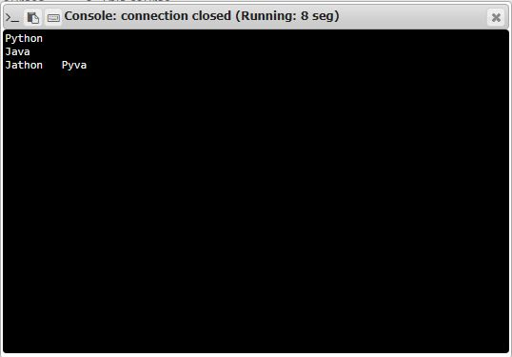

**Result**

Thus,the code has been sucessfully executed and output is verified.